**What is Classification:**

With given new data points, determining or predicting the class of this data is known as classification

Example: for amazon fine food review, with given new review-text classification is to determine whether the given review is +ve or -ve.

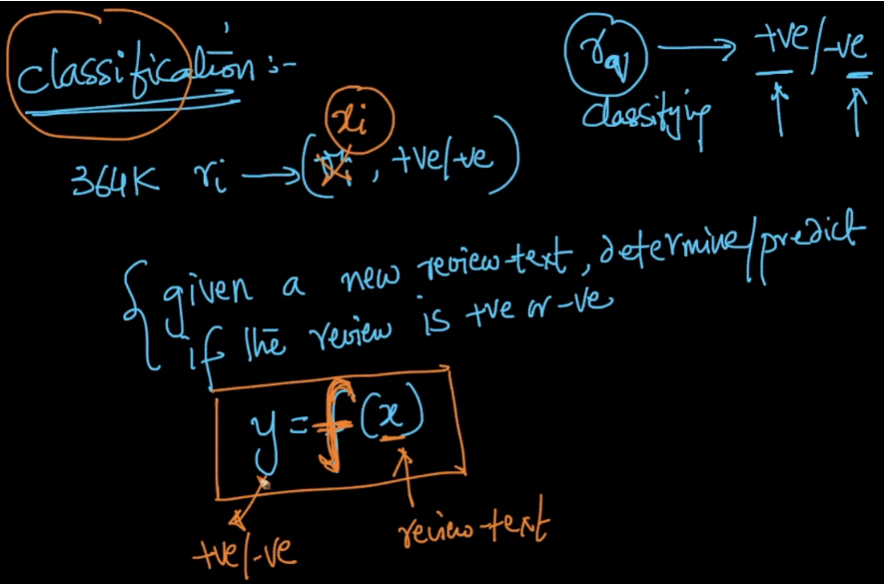

**How Classification Works**:

Classification algorithms would get trained with given training dataset, which would generate a function f(x), which on applying to any new data will determine it’s class or to which class it belongs.

Example: for amazon fine food review, we provide the training dataset and classification algo will generate a function, which on providing a new data will say whether the data belongs to +ve review or -ve review.

Note: Function wrt to machine learning means any ML algorithm having its own parameters that learns mapping from input to output and give prediction on unseen data

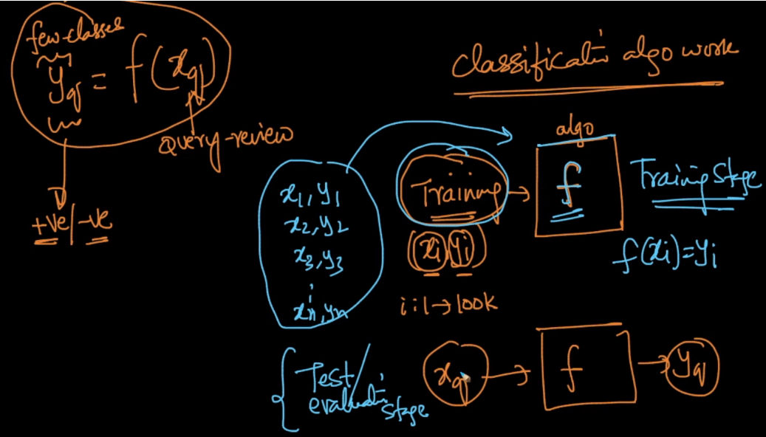

**Machine learning algorithms are described as learning a target function (f) that best maps input variables (X) to an output variable (Y): Y = f(X)  
This is a general learning task where we would like to make predictions in the future (Y) given new examples of input variables (X). We don’t know what the function (f) looks like or its form (it is different for different algorithm we use). If we did, we would use it directly and we would not need to learn it from data using machine learning algorithms**

**Diff b/w fit and fit_transform:**

